# Rationale

I started my design process by building some mock ups based on websites I had used and liked features of. When designing my website, I decided to take the mobile first approach, more specifically the “progressive advancement” approach (Xia, 2017). Therefore, the first mock up created was the mobile version of the website and built my elements scaling up from mobile.

## Mobile

**Mock up. 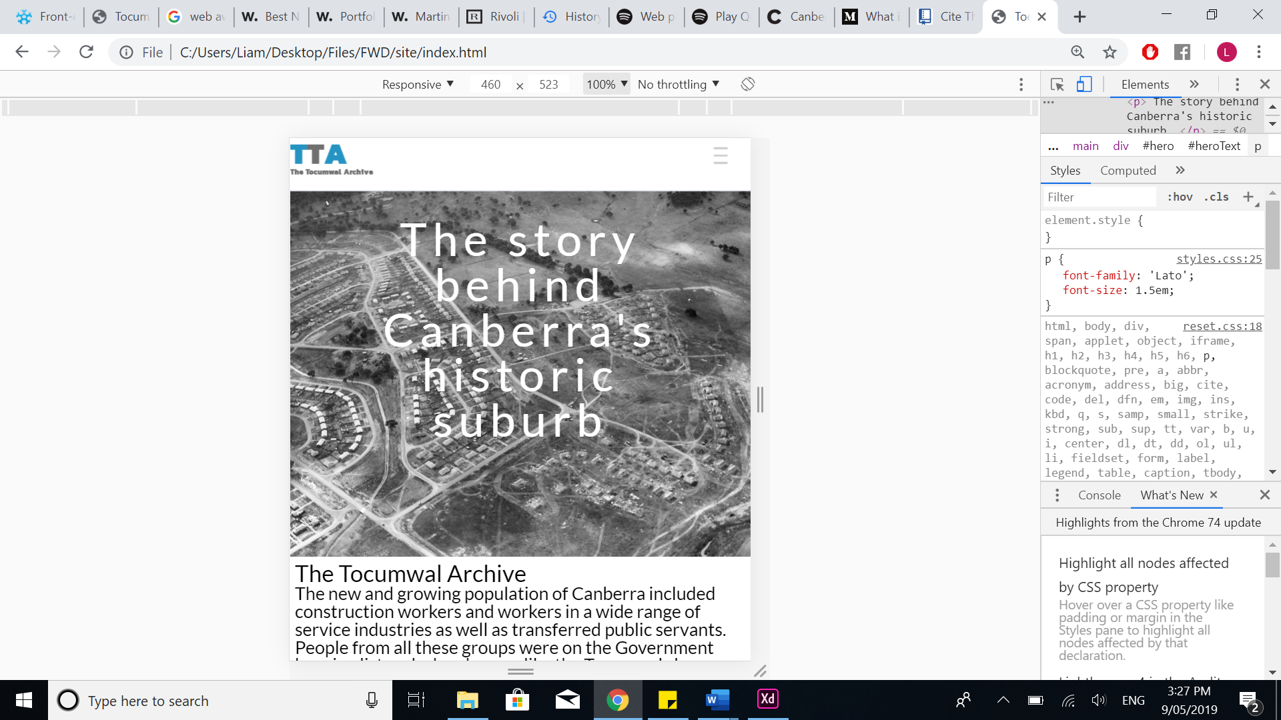Full Site.**

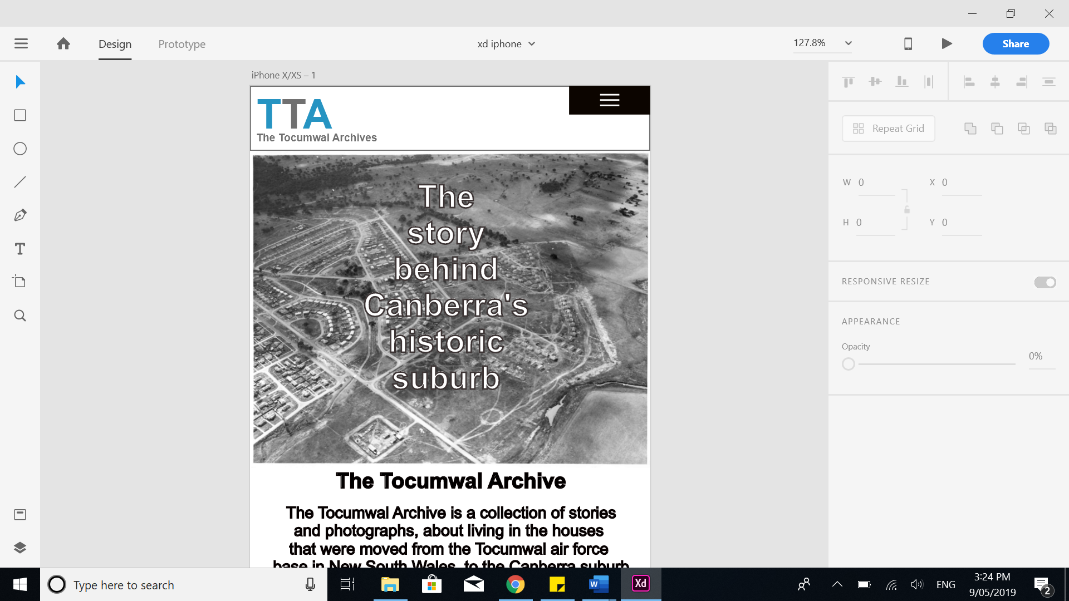

There were a few variations from the mock in the final site. One obvious difference is the styling of the hamburger menu, stylistically I found the more understated hamburger to be more appealing and that the solid black weighed down the lightness of the colour scheme of the website significantly. Another difference is the text outline on the hero content text, the reason this was left out was, from my research there is no reliable function for adding an outline to text in CSS, while this makes the text a little harder to read I decided to keep this style as I much preferred the appearance compared to other options I tired. The final change was the text viewable on the mobile version, the alignment of the text was changed from centre to left as well as the text being changed from bold to normal to make it more readable and this continues through all device sizes.

A feature unique to the mobile version is the hamburger navigation, the functionality was achieved by hiding a check box over the hamburger icon so when the user clicks on it the menu remains on the screen until unchecked. This was inspired by the example seen on *Pure CSS Hamburger fold-out menu* by Erik Terwan. This can be seen from line 110 of the CSS as well as the technique used to animate the hamburger into a cross.

The implementation of the Hamburger proved to be far more challenging than first expected, initially I tried to use the :active pseudo class to achieve the slide out menu however, the element would immediately disappear when no longer being clicked on, which obviously is not viable for a mobile menu as users cannot remain continuously clicked like on a desktop. This led me to using the check box, as it would remain checked until clicked again.

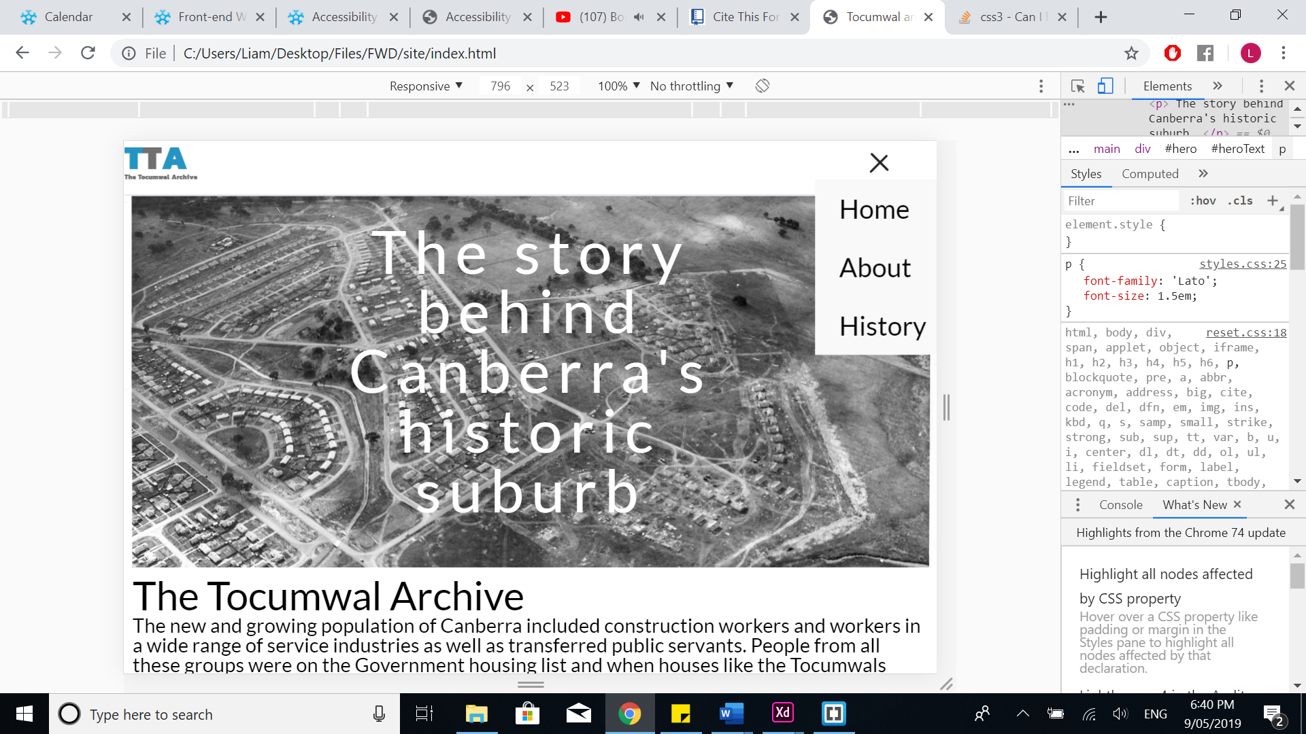

## Tablet

**Mock Up.**

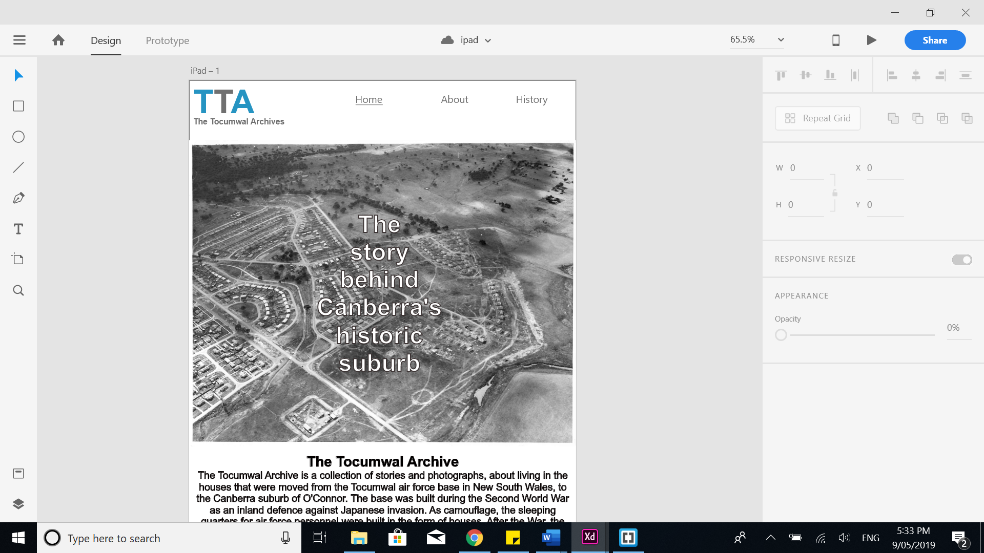

**Full site.**

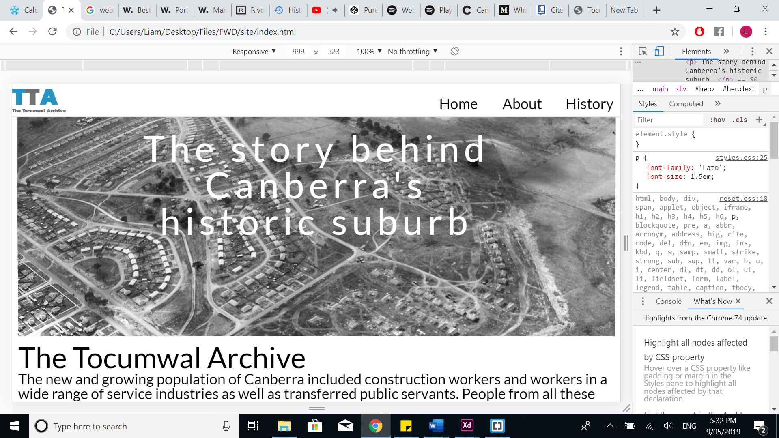

Other than a few placement changes of particular elements the Ipad version remains mostly the same except for the change from the hamburger to the full nav menu, I had originally considered leaving the hamburger for the ipad and only having the full navigation options for the desktop but it left the header looking quite sparse with far too much white space

## Desktop

**Mock up.**

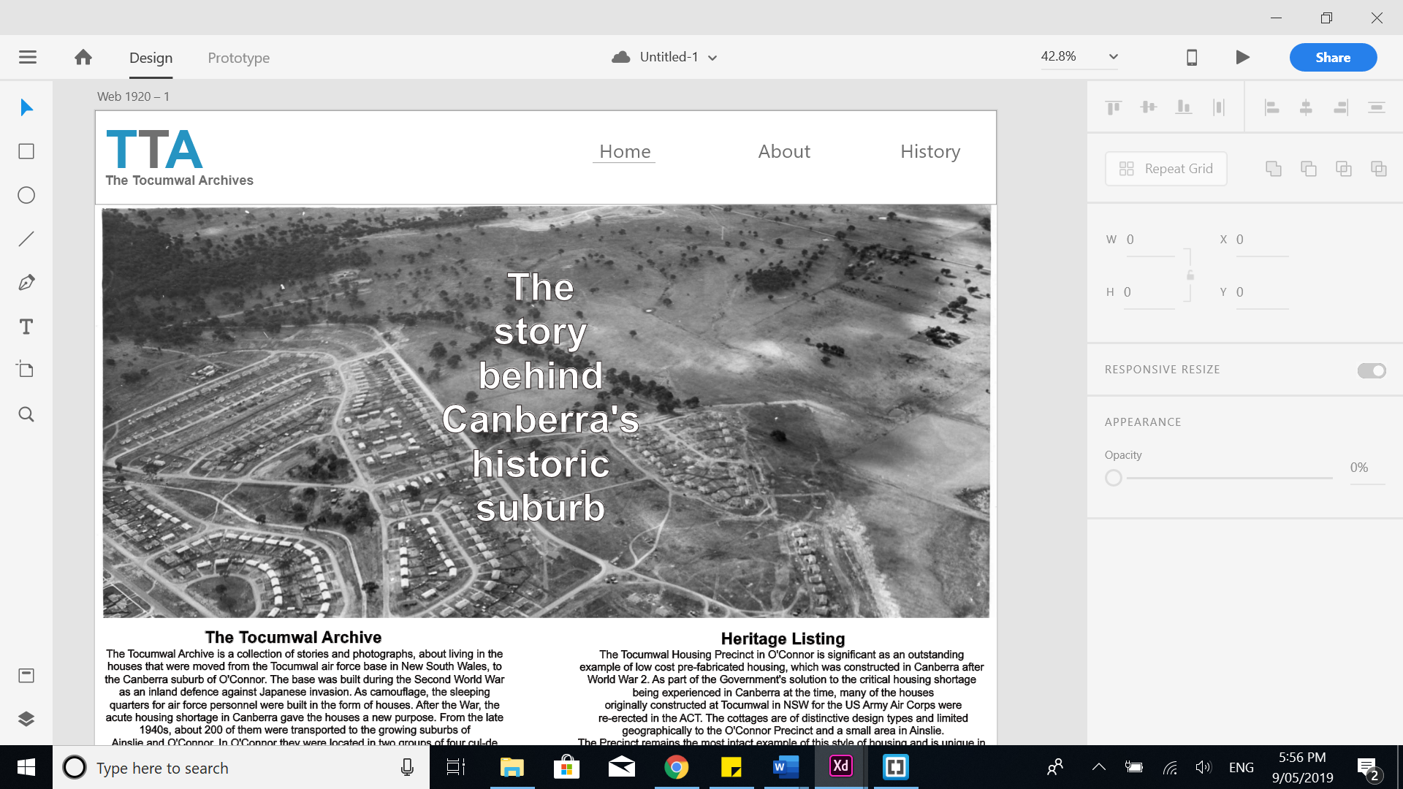

**Full site.**

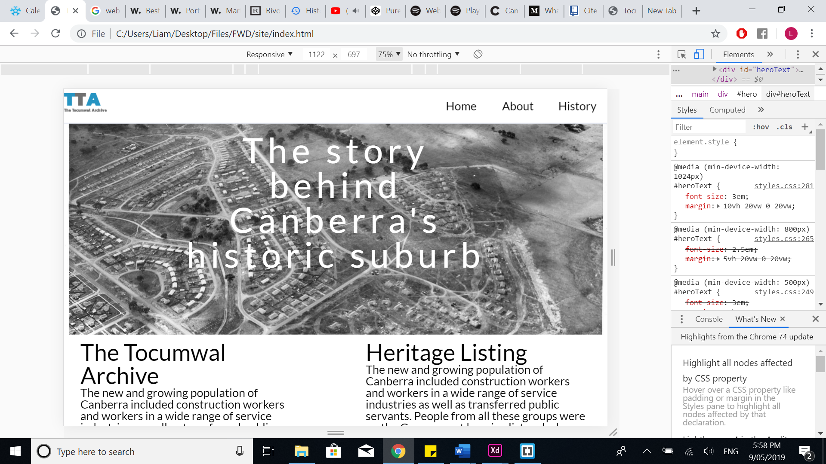

There is very little functional different between the mock up and full site. One minor change is the removal of the underline underneath the active navigation button, this could have easily been achieved by adding the :active pseudo class to the element in the CSS. However, I decided to implement a few other tactile options for the user, such as the transitioning when hovered over to show that it is clickable as well as the mouse turning into a pointer. As well as this the full site transitions to two columns displayed across the page from the one shown in the mobile devices, as a single column looked quite stretched across the desktop size, this was achieved using a CSS grid.

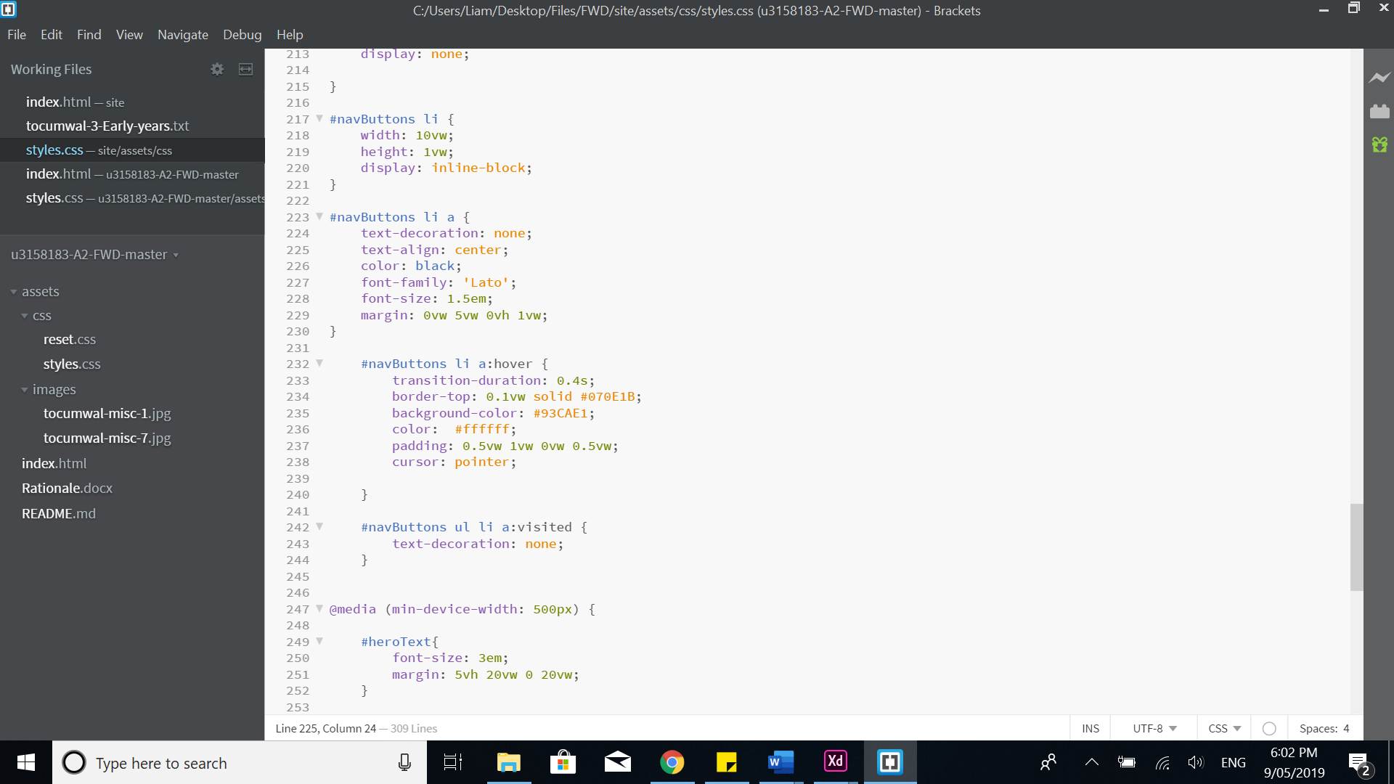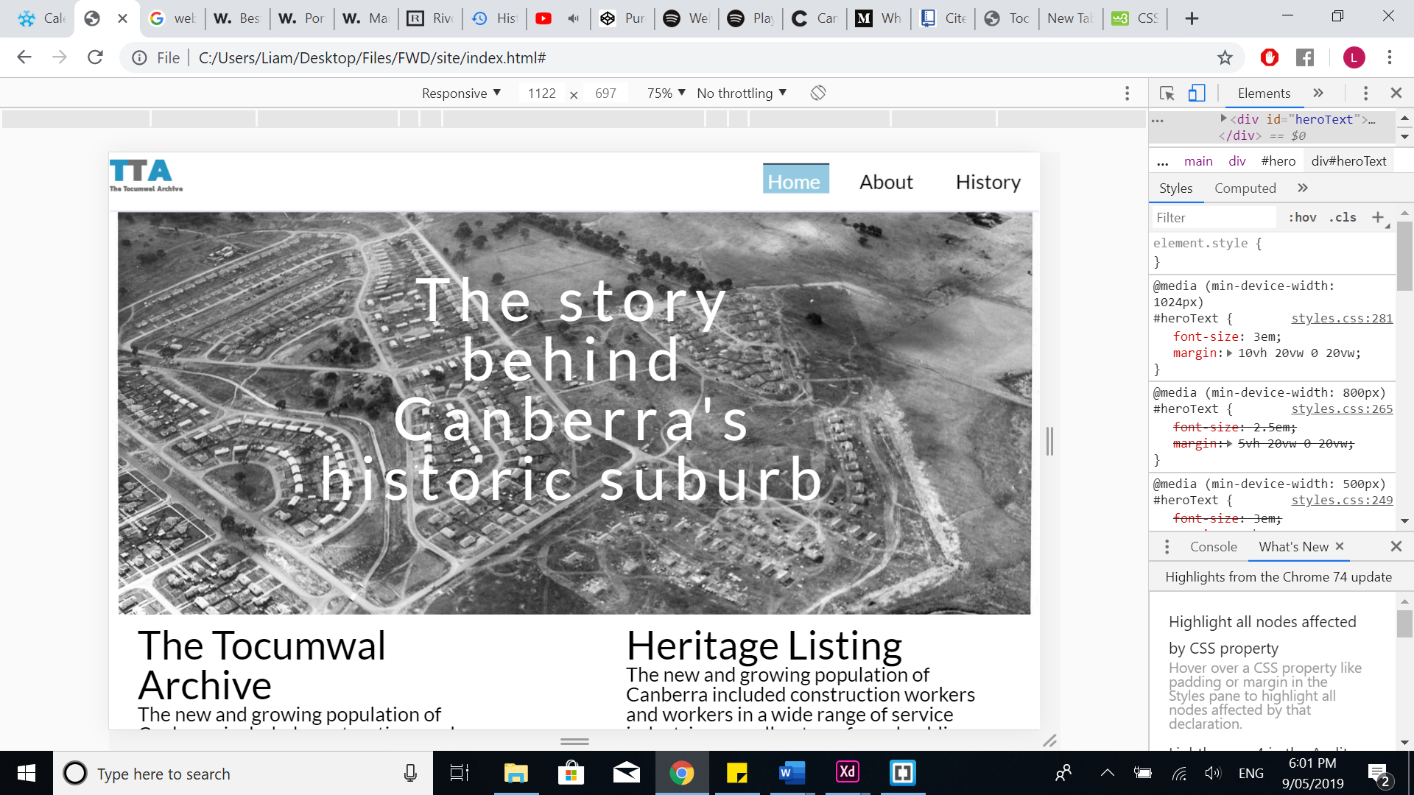

## Design

The design of my navigation and hero content was inspired somewhat by CbrMMA, the idea for the sticky header as well as the parallax scrolling of the hero content came from this site. I decided to reuse the logo from my assignment 2 which was inspired by the logo of the NAA. I also decided to round the edges of the images to soften the appearance as recommended in “*rounded Corners and Why They Are Here to Stay”* and make it easier to view for the user.

I decided to eschew adding a footer as I decided there was little added functionally provided by including it and preferred the sleeker look without it.

# Accessibility audit

|  |  |  |
| --- | --- | --- |
| Item being assessed | assessment result | Implemented fix |
| [1.1.1](https://www.w3.org/WAI/WCAG21/quickref/?versions=2.0#non-text-content) – Non-text Content - Provide text alternatives for non-text content | All images have alt tags that explain their content. | No fix required |
| [1.3.1](https://www.w3.org/WAI/WCAG21/quickref/?versions=2.0#info-and-relationships) – Info and Relationships - Logical structure | All elements are contained in appreciate semantic tags, which follow a logical structure such as h2 not being placed higher on the page than h1. | No fix required. |
| [1.3.2](https://www.w3.org/WAI/WCAG21/quickref/?versions=2.0#meaningful-sequence) – Meaningful Sequence - Present content in a meaningful order | Content is structured logically, navigation at the top follow by hero content and ended by text information. | No fix required. |
| [1.4.1](https://www.w3.org/WAI/WCAG21/quickref/?versions=2.0#use-of-color) – Use of Colour - Don’t use presentation that relies solely on colour | Colour does not indicate functionality. Nav buttons change colour but cursor also changes to denote function. | No fix required. |
| [1.4.2](https://www.w3.org/WAI/WCAG21/quickref/?versions=2.0#audio-control) – Audio Control - Don’t play audio automatically | No audio on site. | No fix required. |
| [2.1.1](https://www.w3.org/WAI/WCAG21/quickref/?versions=2.0#keyboard) – Keyboard - Accessible by keyboard only | Navigation is possible with keyboard only. | No fix required. |
| [2.1.2](https://www.w3.org/WAI/WCAG21/quickref/?versions=2.0#no-keyboard-trap) – No Keyboard Trap - Don’t trap keyboard users | When tabbing across screen no element traps the user. | No fix required. |
| [2.3.1](https://www.w3.org/WAI/WCAG21/quickref/?versions=2.0#three-flashes-or-below-threshold) – Three Flashes or Below - No content flashes more than three times per second | Only animated content does not flash. | No fix required. |
| [2.4.2](https://www.w3.org/WAI/WCAG21/quickref/?versions=2.0#page-titled) – Page Titled - Use helpful and clear page titles | Title set as A3, does not inform user in this context. | Changed title to “Tocumwal archive” |
| [2.4.3](https://www.w3.org/WAI/WCAG21/quickref/?versions=2.0#focus-order) – Focus Order - Logical order | No internal navigation present on page. | No fix required. |
| [2.4.4](https://www.w3.org/WAI/WCAG21/quickref/?versions=2.0#link-purpose-in-context) – Link Purpose (In Context) - Every link’s purpose is clear from its context | Links are placed in either the header for navigation or drop-down hamburger, which makes their purpose clear. | No fix required. |
| [3.1.1](https://www.w3.org/WAI/WCAG21/quickref/?versions=2.0#language-of-page) – Language of Page - Page has a language assigned | Lang is set to “en”. | No fix required. |
| [4.1.1](https://www.w3.org/WAI/WCAG21/quickref/?versions=2.0#parsing) – Parsing - No major code errors | Both HTML and CSS pass validation test. | No fix required. |

# Audit Summary

With only one change required this audit can be considered extremely successful, the reason there were so few issues with accessibility was the method I used to design the website. From the inception of my mock ups I attempted to plan the accessibility of the elements as I was designing them so very little later development would be required. With the successful implementation of this audit this website should not prevent users from enjoying its full functionality, especially users with disabilities or limited access to technology.

# References

Bryant, K. (2012). *Rounded Corners and Why They Are Here to Stay - Designmodo*. [online] Designmodo. Available at: https://designmodo.com/rounded-corners/ [Accessed 7 May 2019].

Cbrmma.com.au. (2019). [online] Available at: http://cbrmma.com.au/ [Accessed 9 May 2019].

National Archives of Australia. (2019). *National Archives of Australia*. [online] Available at: http://www.naa.gov.au/ [Accessed 7 may. 2019].

Terwan, E. (n.d.). [online] Available at: https://codepen.io/erikterwan/pen/EVzeRP [Accessed 9 May 2019].

Xia, V. (2017). *What is Mobile First Design? Why It’s Important & How To Make It?*. [online] Medium. Available at: https://medium.com/@Vincentxia77/what-is-mobile-first-design-why-its-important-how-to-make-it-7d3cf2e29d00 [Accessed 7 May 2019].